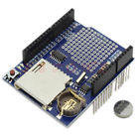**Logging Recorder Data Logger Module Shield V1.0 for Arduino UNO SD Card**

**New Data Logger Module Logging Recorder Shield V1.0 for Arduino UNO SD Card**

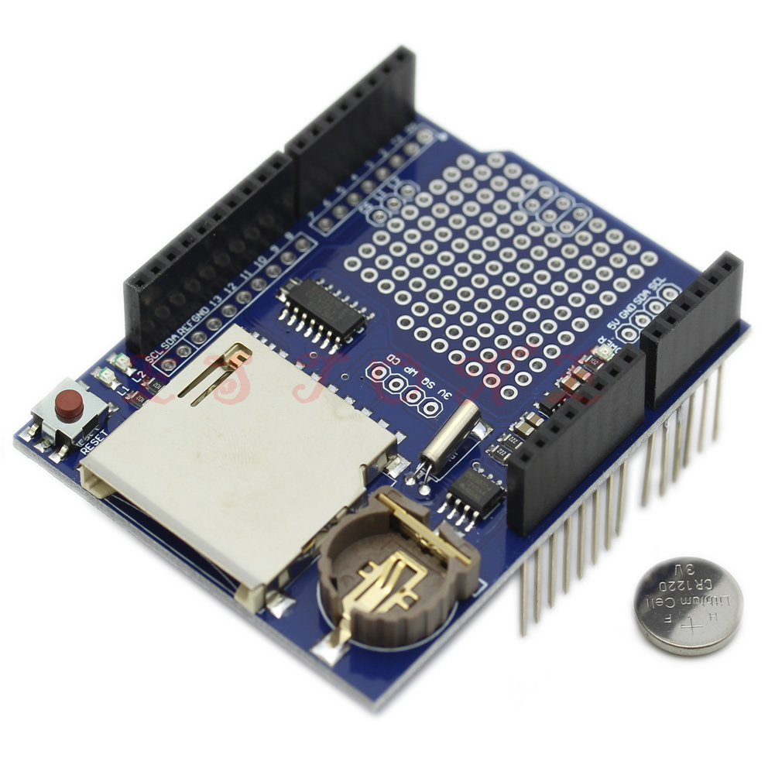

 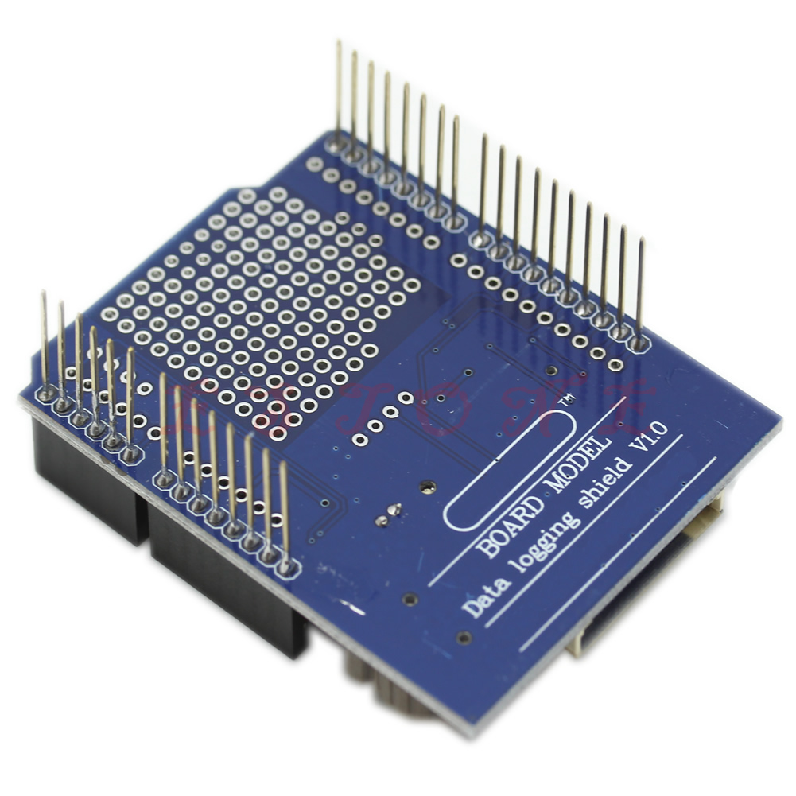 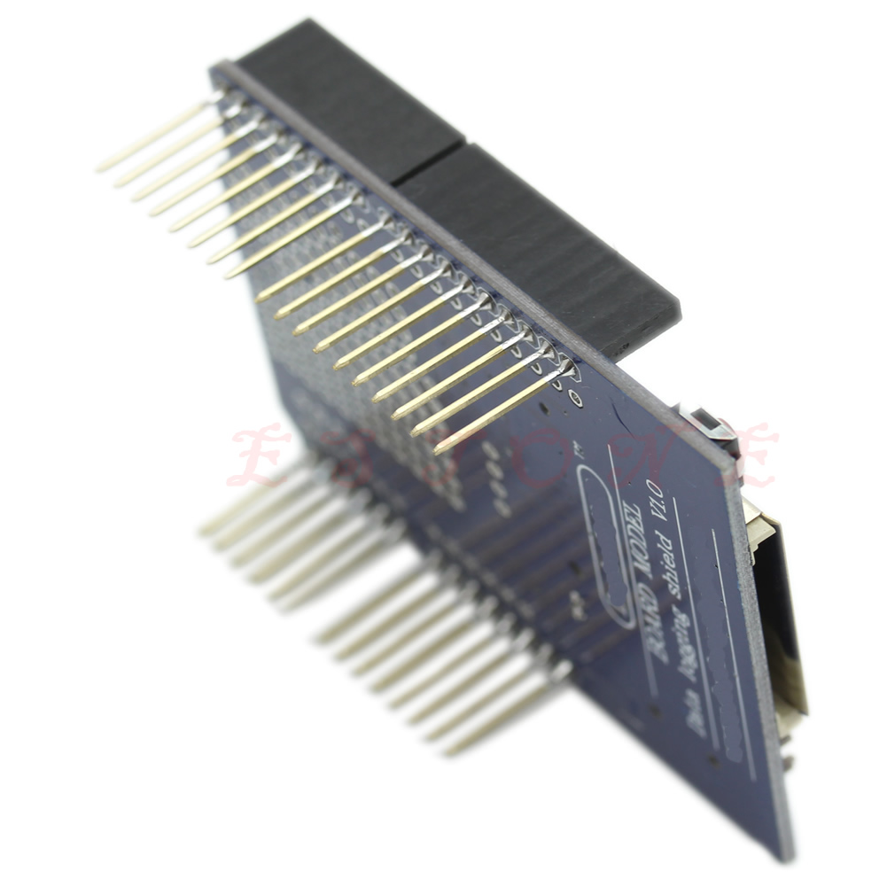

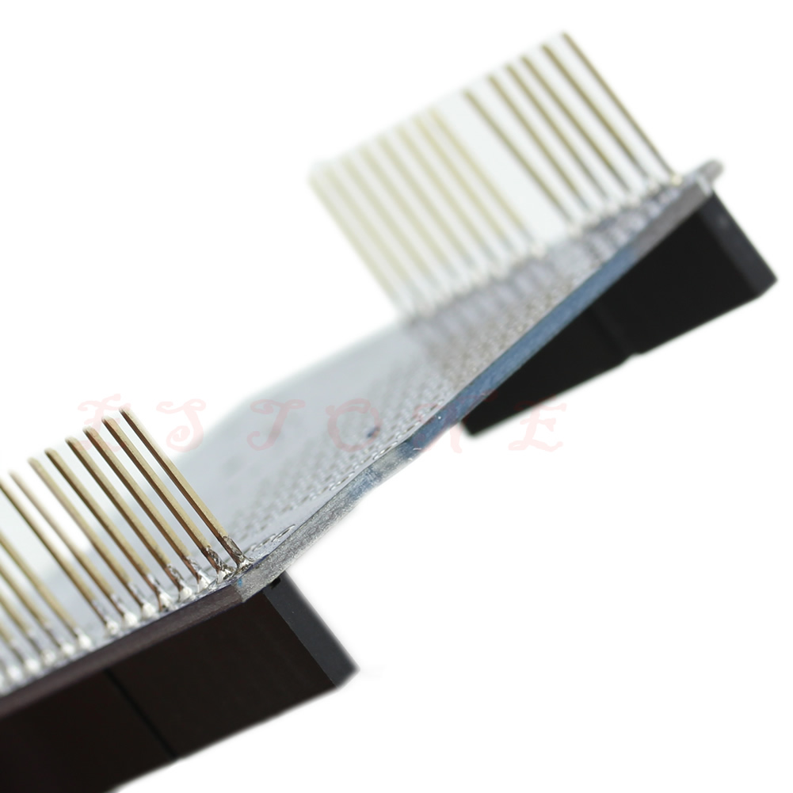

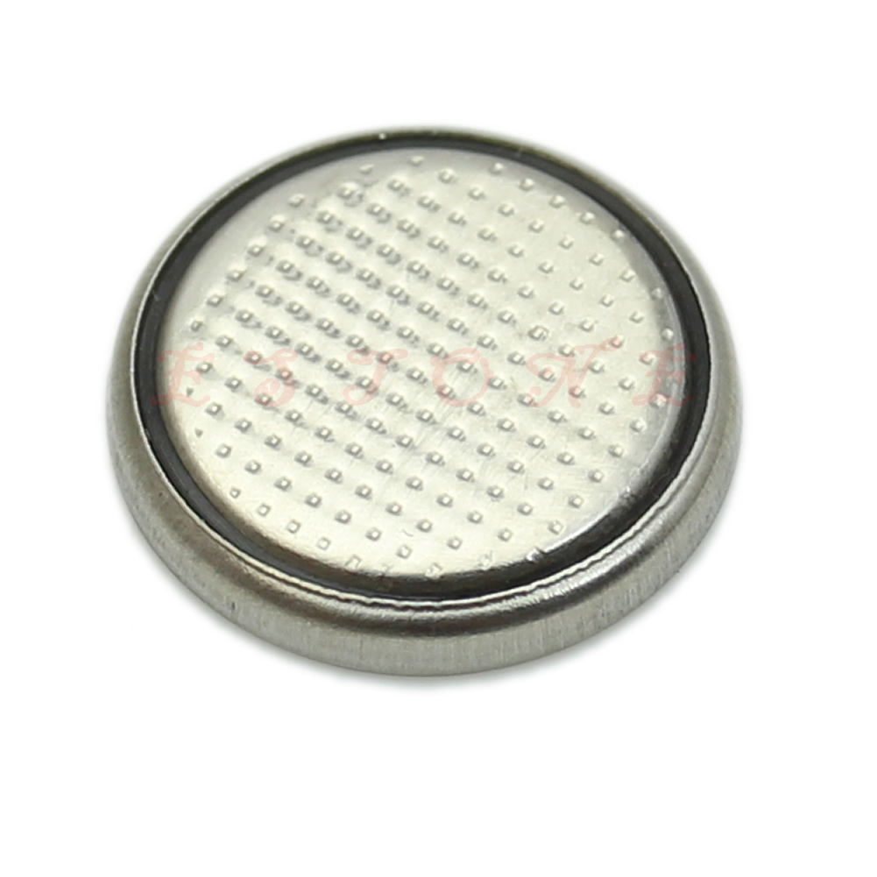

**Description:**

* **100% brand new and high quality.**
* SD card interface works with FAT16 or FAT32 formatted cards. 3.3v level shifter circuitry prevents damage to your SD card
* Real time clock (RTC) keeps the time going even when the Arduino is unplugged. The battery backup lasts for years
* Included libraries and example code for both SD and RTC mean you can get going quickly Prototyping area for solderingconnectors, circuitry or sensors.
* Onboard 3.3v regulator is both a reliable reference voltage and also reliably runs SD cards that require a lot of power to run
* Works with Arduino UNO, Duemilanove, Diecimila, Leonardo or ADK/Mega R3 or higher. ADK/Mega R2 or lower are not supported
* Size:68x53x23mm(approx)
* Note: Due to **the difference between different monitors, the picture may not reflect the actual color of the item. Thank you!**

**[Download](http://www.winddeal.net/image/tools/28219.rar)**

**Package includes:**

* **Data Logger Module x 1**
* **Lithium Cell x 1**